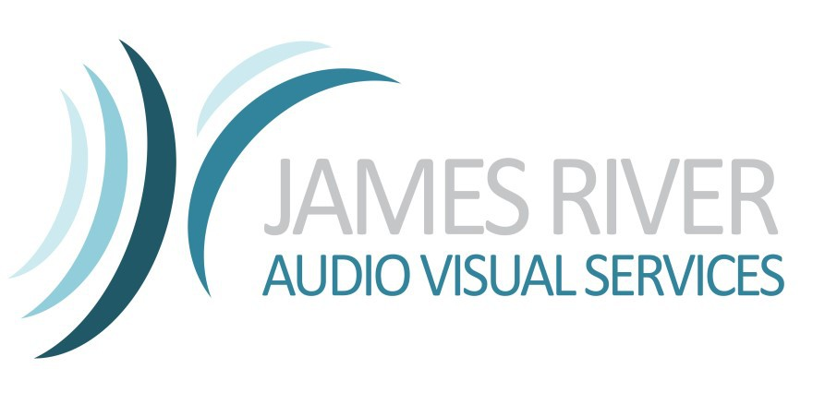
James River Audio Visual Services offers a wide variety of Pro-AV equipment to accommodate meeting and event solutions for groups of all sizes. From an executive board meeting to a major staging event, you can count on the professional experienced staff at JRAVS to attend to every detail and ensure that your event is a benchmark experience.

Booth Name:

Company:

Address:

City: State & Zip:

On-site Contact: On-site Cell:

Phone: Email:
Booth Number:

Ordered By:

Requested Delivery Date:

Select One:

8am-10am 10am-12noon 1pm-3pm 3pm-5pm Requested Return Date:

Select One:

8am-10am 10am-12noon 1pm-3pm 3pm-5pm

ALL PRICING IS PER DAY *Contact us for items not listed

LCD Monitors

32” LCD MONITOR
46” LCD HDTV/MONITOR with Stand

60” LCD HDTV/MONITOR with Stand

70” LCD HDTV/MONITOR with Stand

56” LCD HDTV/MONITOR with Truss Stand

Audio Systems

Shure 4 Channel Mixer/Samson Mixpad
Shure SLX Wireless Handheld or Lavaliere Microphone

Samson Battery Powered Speaker System

JBL EON-15 15” Powered Speaker with Stand–
Misc. Meeting Equipment

Laser Pointer

Wireless RF Computer Mouse Remote

Projection Carts w.Skirt (24”-54”)

Flipchart w. 40 Sheet Pad

Flipchart w. 3M Post-It Pad

Tripod Prop Easel

Tripod Screens

Draper 60” diagonal “Insta Screen”

5’X5’- 10’ Diagonal Tripod Screens

QTY Number of Days

QTY Number of Days

QTY Number of Days

QTY Number of Days

Daily Rate Total

$125
$150

$200

$250

$600

Daily Rate Total

$45
$125

$45

$50
Daily Rate Total

$25

$25

$25

$35

$45

$10

Daily Rate Total

$45

$45

Email completed form to: Davidb@JRAVS.COM and an invoice will be generated and returned by email with option to pay with credit card. Please call 757-342-2502 with any questions. A $45 delivery charge will be added to each order. 7% sales tax added
ALL PRICING IS PER DAY *Contact us for items not listed

Projector (4k-5k Lumens)

Eiki LC-WBS500 WXGA 5,000 Lumen Desktop Projector with VGA & HDMI Inputs

Christie LWU701i-D WUXGA 7,000 LCD Projector w. Interchangable Lens
Video Playback Units

Standard DVD Player

“Blu-Ray” High-Definition DVD Player

Lighting

CromePar 38 (Uplight)

ADJ Battery Powered LED

Elation Tri-Brick Intelligent LED
10’ 12”X12” Light Duty Truss (price Per Section)

Optional Equipment (please call for pricing)

Presentation Computer

Laptop w. MS Office
Mac Laptop w. Playback Pro
Laptop Audio Patch

QTY Number of Days

QTY Number of Days

QTY Number of Days

QTY Number of Days

QTY Number of Days

Daily Rate Total

$175

$450
Daily Rate Total

$50

$75

Daily Rate Total

$15

$25

$35
$50

Daily Rate Total

Daily Rate Total

$100
$225
$25

Please let us know what content source(s) will be used, if providing your own:

PC LAPTOP: (please select output below) iPad or MAC: (please select output below)

HDMI VGA DISPLAY PORT MINI DISPLAY PORT 30pin LIGHTNING- MINIDISPLAY PORT THUNDERBOLT

DVD PLAYBACK DEVICE: (please select output below OTHER SOURCES: (please specify output )

HDMI VGA COMPONENT COMPOSITE

I agree to rent & accept the above listed equipment & acknowledged that it is in good working condition & agree to pay James River Audio Visual Services a stipulated rental price & agree to take care of all equipment & use in a proper manner & agree that in the event any of the rented equipment is lost or destroyed before it is returned, to pay JRAVS accrued rental monies plus the full value of rented property.

Accepted By: Accepted Date:

For Custom quotes for your specific event

Call: 919-740-5662

Email: Davidb@JRAVS.com

JRAVS.com

